NORTHERN EDUCATION DIVISION
2026 MSCE MOCK EXAMINATIONS
PHYSICS
Subject Number: M164/II
Friday, -- March, 2026
Time Allowed: 2-hour sessions
10:00 onwards
PAPER II
Practical
(100 Marks)

Instructions
- This paper contains 6 printed pages. Please check.

- Write your Name at the top of the question paper and on all other sheets.

- Answer all the thirteen questions in the spaces provided.

- Use of electronic calculators is allowed.

- Maximum number of marks for each answer is indicated against each question.

- In the table provided on this page, tick against the question number you have answered.

- At the end of the examination, hand in your paper to the invigilator when time is called to stop writing.

Question Number | Tick if answered | Do not write in these columns
1
2
3
4
Total

©NED2026 Turn over

Section A (20 Marks)
Answer all the question in this section.

- With the aid of well labelled diagrams describe an experiment that can be carried out to demonstrate that resistance of a media affects the speed of an object falling through the media. Your description should include: 2 identical ball bearings, water, oil, 2 transparent jars of the same size.
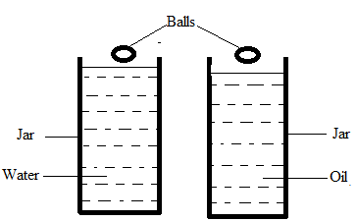

Marks allocation on the diagram.
- 1 mark for correct diagram.
- 2 marks for two correct labels (1 mark for each correct label).
Procedure:
- Arrange the materials as shown above.
- At the same (1 mark) time, /release or drop (1 mark) one ball in the jar containing water and another in the jar with oil.
- Record time taken (1 mark) /for each ball to reach the bottom (1 mark) of the jar.
- Compare the times (1 mark) taken for the balls to reach the bottom.
- Deduce the relationship OR If the time taken is different (1 mark), then the resistance of the medium affects the speed (1 mark) of an object falling in through the medium.
(10 marks)

- Describe an experiment that can be carried out to determine the length of a wire of resistance of 2 Ohms given a roll of wire.
-connect a series circuit with a voltmeter, ammeter and a gap across the voltimeter (2)
-measure any reasonable length L1 of a wire from the roll using a ruler.(1)
-connect the wire of known length across the gap.(1)
-note the voltmeter and ammeter readings.(1)
-record the voltmeter and ammeter readings.(1)
-calculate resistance R1 by dividing voltage by current.(2)
- let 2ohms be resistance R2 for the corresponding length L2 of the wire .
-calculate length L2 by using the formular L2 = (L1/L2) R2 (2) (10 marks)

- You are provided with a convex lens, a meter ruler, lens holder, white screen, a candle and matches.
- Arrange the apparatus as shown in figure 1.
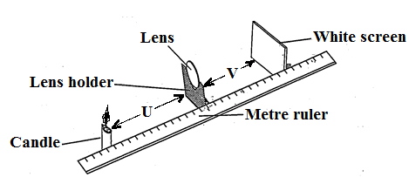
Figure 1`
- Place a candle at a distance of 15 cm from centre the lens (u).
- Light the candle.
- Move the screen until a clear image of the candle flame is focused onto the white screen.
- Measure the distance from the screen to the centre of the lens (v) and record in the table of results.
Table of results
Object distance (u), cm | Image distance (v), cm
15 | 30 $±$ 1
20 | 20 $±$ 1
30 | 15 $±$ 1
40 | 13 $±$ 1
1 mark decreasing trend of image distance (v)
Note: - 1 mark for any 2 correct values within range
- 2 marks for 3 correct values within the range
- 3 marks for any 4 to 5 correct values within the range
(4 mark
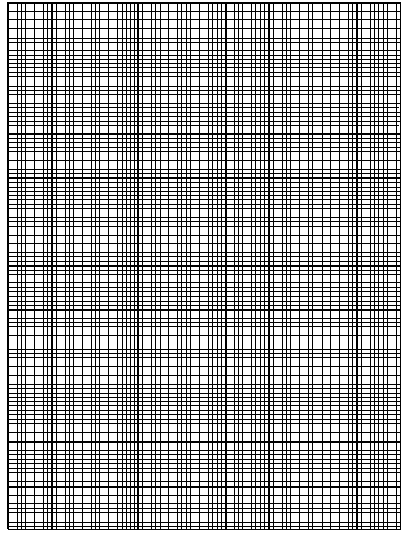
1 mark for correct scale and correct labelling of both axes
1 mark for correctly locating any 2 points
i.e 2 marks for correctly locating 4 – 5 points
1 mark for the graph line (smooth curve)
- From the graph what would be the image distance, v when the object distance, u is 20 cm.
- 20 cm (1 mark)
- Use the graph to find the focal length of the lens.
U = V = 20
2f = 20 1 mark
F = 10 cm 1 mark for correct answer

(4 marks)
- You are provided with a spring balance and masses of 100g and 200g.
  - Arrange the materials as shown in the figure 2 below.
100g spring balance
Pull
Desk

  - Pull the mass until when it just starts moving.
  - Note and record the reading from the spring balance in the table of results below.
  - Repeat the steps b. and c. using 200g mass.
Mass (g) | Reading of spring balance (N)
100
200
2 marks
  - Convert 200g to weight.
Weight = normal reaction force(1) = 200g x 1N (1)
100g
= 2N (1)
3 marks
  - Use the result in e to find coefficient of friction.
Depending value obtained experimentally.
3 marks
  - Suggest one error in this experiment.
-incorrect reading/ using only one value.
1 mark
  - Suggest a way of minimizing the error in g.
- Repeating the experiment to use the average value. 1 mark

